28.27: a) 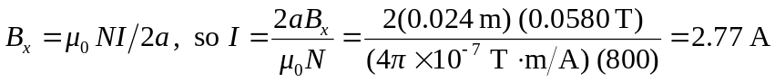
b) At the center, 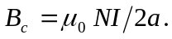 At a distance x from the center, 